MAT 243 Project One Summary Report

Tim Chu
tim.chu@snhu.edu
Southern New Hampshire University

Introduction: Problem Statement
The purpose of this analysis is to look at historical NBA data to better understand team performance and scoring patterns. I will analyze the New York Knicks from 2013 to 2015 and compare their performance to the Chicago Bulls from 1996 to 1998. The data includes information about points scored, team skill level, year, and game location. I will use data visualizations, descriptive statistics, and confidence intervals to analyze the data. These methods will help show patterns in team performance and allow the two teams to be compared.

Introduction: Your Team and the Assigned Team
Name of Team | Assigned Years
New York Knicks | 2013-2015
Chicago Bulls | 1996-1998

For this project, I selected the New York Knicks and analyzed their performance from 2013 to 2015. The assigned team used for comparison is the Chicago Bulls from 1996 to 1998. Comparing these teams will help show differences in their scoring performance during the selected time periods.

Data Visualization: Points Scored by Your Team
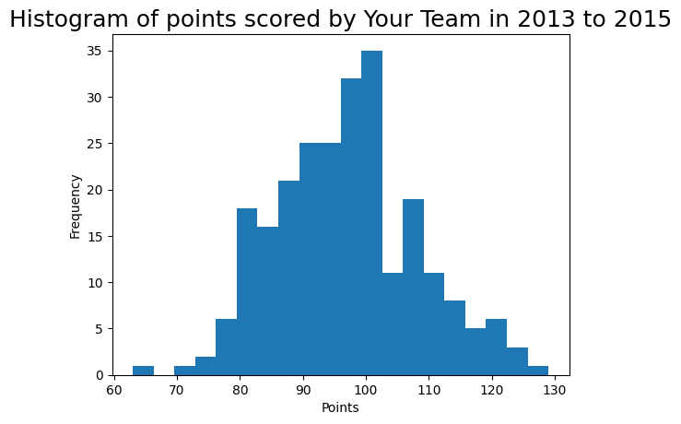
Data visualizations make it easier to see patterns and trends that may not be obvious from looking at the raw data. I chose the histogram because it clearly shows the distribution of points scored by the New York Knicks from 2013 to 2015. Most of the games are grouped around the middle of the distribution, with fewer games at the very high and very low ends. The distribution appears fairly bell-shaped, which shows that the Knicks usually scored around their typical range of points, while extremely high or low scoring games happened less often.

Data Visualization: Points Scored by the Assigned Team
I also chose the histogram for the Chicago Bulls because it makes the distribution of their points scored easy to see. The Bulls' scores are mostly concentrated around the center of the distribution, with fewer games at the highest and lowest point totals. The distribution appears fairly bell-shaped overall. The histogram also shows that the Bulls generally scored more points per game than the Knicks during the years being analyzed.
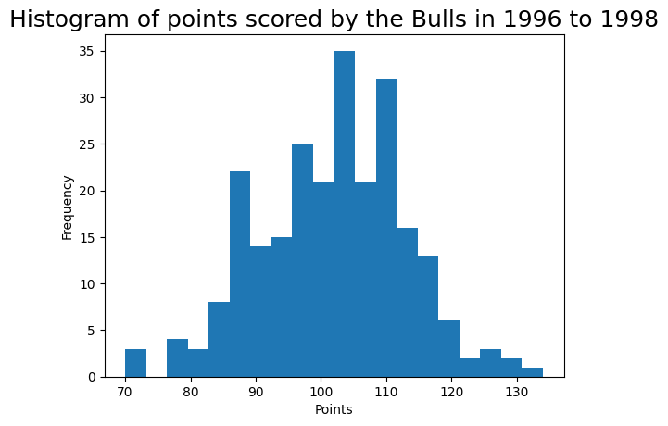

Data Visualization: Comparing the Two Teams
Data visualizations can be used to compare distributions by showing differences in their centers, spreads, and ranges. I chose the side-by-side boxplot because it makes it easy to directly compare the points scored by the Knicks and Bulls. The Bulls' distribution is centered higher than the Knicks' distribution, showing that the Bulls generally scored more points per game. There is still overlap between the two teams, but the Bulls tended to have higher scoring performances overall.
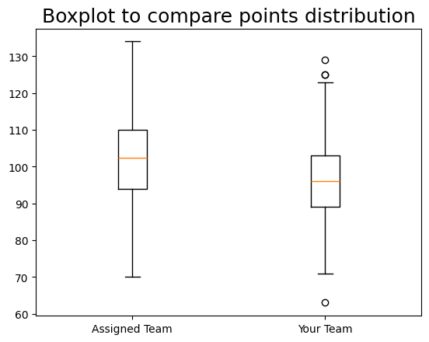

Descriptive Statistics: Points Scored By Your Team in Home Games
Table 2. Descriptive Statistics for Points Scored by Your Team in Home Games
Statistic | Value
Mean  Median  Variance  Standard Deviation | 95.67  95  129.06  11.36

Measures of central tendency and variability help describe the center and spread of a data distribution. For Knicks away games, the mean number of points scored was 95.67 and the median was 95.00. Since the mean and median are very close, the distribution appears to be fairly balanced and approximately bell-shaped rather than strongly skewed. The variance was 129.06 and the standard deviation was 11.36, meaning that the number of points scored typically varied by about 11.36 points from the mean. Because the distribution is fairly balanced, the mean is a good measure to use to represent the center of the distribution.

Descriptive Statistics: Points Scored by Your Team in Home Games
Table 3. Descriptive Statistics for Points Scored by Your Team in Away Games
Statistic Name | Value
Mean  Median  Variance  Standard Deviation | 98.03  98  120.61  10.98
For Knicks home games, the mean number of points scored was 98.03 and the median was 98.00. The mean and median are almost identical, which indicates that the distribution is fairly balanced and approximately bell-shaped. The variance was 120.61 and the standard deviation was 10.98, showing that home-game scores typically varied by about 10.98 points from the mean. The mean is an appropriate measure of the center because there does not appear to be strong skew in the distribution. The Knicks performed slightly better at home than away because their average home score was 98.03 compared with 95.67 away. The standard deviation was also slightly lower at home, 10.98 compared with 11.36 away, which means their home scoring was slightly more consistent.

Confidence Interval to estimate the True Potential of Your Team
Confidence Level (%) | Confidence Interval
95% | (95.41, 98.21)

Confidence intervals are used to estimate a range of values that is likely to contain a population parameter, such as the true average. The 95% confidence interval for the average number of points scored by the Knicks from 2013 to 2015 was 95.41 to 98.21 points. This means I am 95% confident that the Knicks' true average points scored under similar conditions falls within this range. If a higher confidence level were used, the interval would become wider because more values would need to be included to increase confidence. A lower confidence level would result in a narrower interval.

Confidence Interval to estimate the True Potential of the Assigned Team
Table 5. Confidence Interval for Average Relative Skill of Teams in Assigned Team’s Years
Confidence Level (%) | Confidence Interval
95% | (100.27, 103.1)

The 95% confidence interval for the average number of points scored by the Chicago Bulls from 1996 to 1998 was 100.27 to 103.10 points. This means I am 95% confident that the Bulls' true average points scored under similar conditions falls within this range. A higher confidence level would produce a wider interval, while a lower confidence level would produce a narrower interval. When the two teams are compared, the Bulls' interval of 100.27 to 103.10 is entirely higher than the Knicks' interval of 95.41 to 98.21. This suggests that the Bulls had a higher point-scoring potential than the Knicks during the time periods analyzed.

Conclusion
The statistical analysis showed several differences between the New York Knicks from 2013 to 2015 and the Chicago Bulls from 1996 to 1998. The Knicks scored slightly more points at home than away and were also slightly more consistent in home games. The visualizations and confidence intervals also showed that the Bulls generally had higher scoring performances than the Knicks. The Bulls had an average of 101.68 points and a 95% confidence interval of 100.27 to 103.10, while the Knicks had a 95% confidence interval of 95.41 to 98.21. These analyses are useful because they turn historical game data into information that management can use to better understand team performance. Overall, the results suggest that game location affected the Knicks' scoring somewhat and that the Bulls had stronger scoring performance during the periods analyzed.

